ORDER DETAILS

This job aid shows you how to create & edit order labels to be used when creating a RunBuggy order.

*CREATING A LABEL*

STEP 1: FROM THE DASHBOARD, CLICK ORDERS.

STEP 2: CLICK THE ICON TO TOGGLE THE GRID VIEW.

STEP 3: CLICK THE ICON.

STEP 4: ENTER THE COLUMN LABEL.

STEP 5: CHOOSE THE COLUMN TYPE. THE COLUMN TYPES ARE AS FOLLOWS:

Text – Allows users to manually enter in information.

Number - Allows users to set a number.

Dropdown - Allows users to choose from a number of custom options.

STEP 5a (OPTIONAL): IF YOU HAVE CHOSEN THE DROPDOWN COLUMN TYPE, ADD OPTIONS FOR USERS TO CHOOSE FROM.

STEP 6: CLICK SAVE.





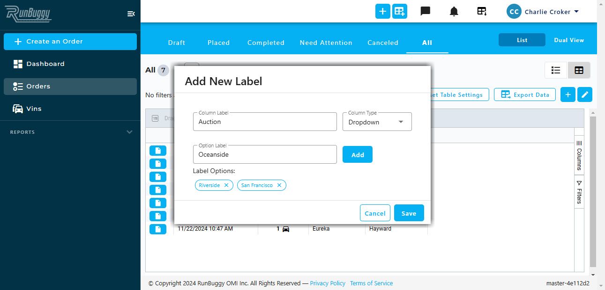



*CUSTOMIZING YOUR LABELS*

STEP 1: FROM THE DASHBOARD, CLICK ORDERS.

STEP 2: CLICK THE ICON TO TOGGLE THE GRID VIEW.

STEP 3: CLICK THE ICON.

STEP 4: CLICK THE ICON NEXT TO THE LABEL YOU WANT TO CUSTOMIZE.

STEP 5: CUSTOMIZE THE ORDER LABEL. YOU ARE ABLE TO DO THE FOLLOWING:

* Rename the label
* Set the label as mandatory
* Add or remove options *(Dropdown labels only)*
* Delete the label

STEP 6: CLICK SAVE.

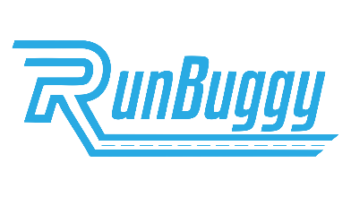

**Ship Cars**

FASTER. EASIER. SMARTER. BETTER.

RunBuggy_OrderDetails_JobAid_v1.0_1203024 | Copyright © 2024 RunBuggy OMI, Inc. All Rights Reserved. RunBuggy Confidential Information - Subject to NDA





